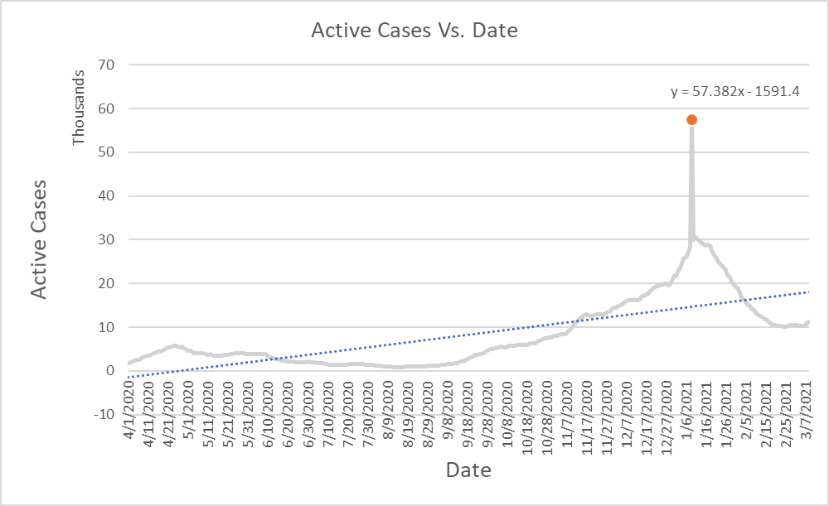

Sum of all the active cases in the data compared to the date they appeared on. This graph was to see the increase over time of how many active cases were appearing during a given time. The trend line also shows that there has been a increase in active cases every since the first cases appears.

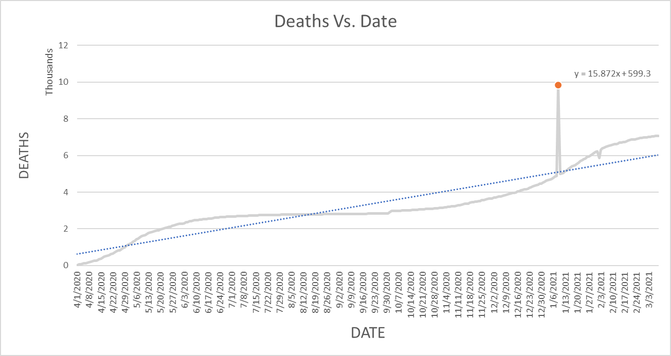

This graph represents the total deaths over dates you can see the spike of deaths occur the date after the spike in “Active Vs. Date” graph, showing that active cases correlate to the death rates in this data.

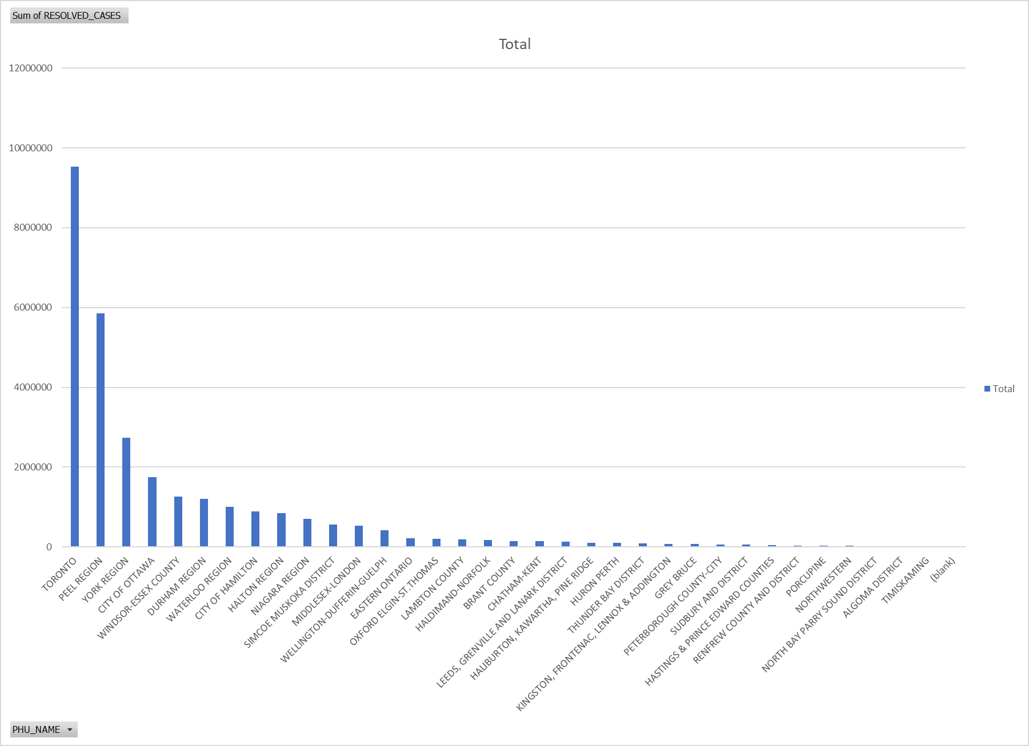

This graph represents the total number of resolved cases for each region in this data. This graph shows that the area with the most cases, also have the most resolved cases, showing that more people are surviving after contracting Covid-19, than dying from it. Graphical user interface, text

This graph is the sum of total deaths vs. sum of total resolved cases, again proving that more people are suriving Covid-19, than dying from it.

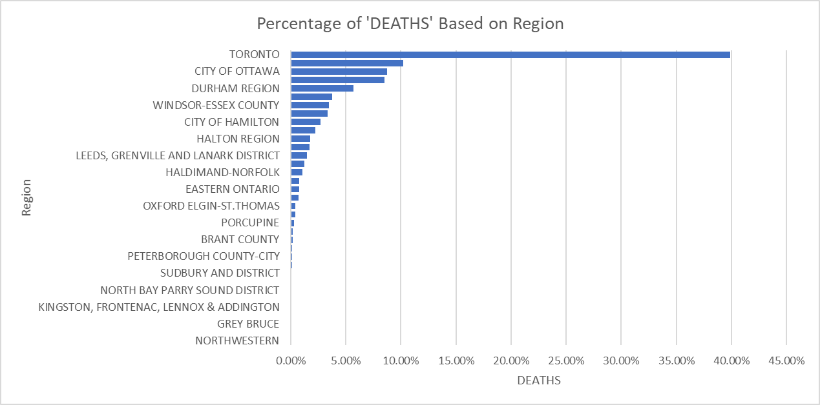

This graph represents the overall percentage of where deaths from Covid-19 are occurring. As you can see, Toronto has the highest precent of Deaths but also the highest resolved cases rate. However, for the city of Ottawa, where they fall 4th on the list of total resolved cases. This graph shows that certain regions in the data have a higher percentage of people dying of covid-19, than others.

This graph shows that top 3 areas where death is occurring from Covid-19. Again proving the point that in certain regions you are more likely to dying due to Covid-19 than others.

